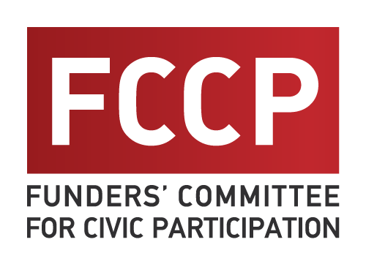  641 S Street NW  3rd Floor  Washington, DC 20001  571-492-4241 | INVOICE
 | Date:

To: | For: FCCP 2019 Annual  Membership dues

FCCP 2019 ANNUAL MEMBER DUES
If your annual giving budget is: | Then your FCCP dues are:
Individual | $250
<$500,000 | $500
$500,000 - $1 million | $1,500
$1 million - $5 million | $3,000
$5 million - $10 million | $4,000
$10 million - $20 million | $5,000
$20 million - $25 million | $10,000
$25 million+ | $15,000+ (at member’s discretion)

DESCRIPTION |  |  | AMOUNT (Select one)
FCCP Annual Membership Dues  Using the chart above to determine your dues, please select the  amount that corresponds to your foundation’s overall grantmaking budget. |  |  | $250  $500  $1,500  $3,000  $4,000  $5,000  $10,000  $15,000
 |  | TOTAL | Please write total

Please make your check payable to NEO Philanthropy (clearly marked for “FCCP 2019 membership dues”) and mail it to FCCP c/o NEO Philanthropy, 45 W. 36th St., 6th Floor, New York, NY 10018.
THANK YOU!

